

KTTL CRM USER MANUAL

**Prepared by: IT Department, Krishibid Group**

Content

Introduction 2

Description of the System 2

1. KTTL CRM Login Page 3

2. Dashboard 4

**2.1 CRM Home Page** 4

2.1.1 Change Password 4

3. KTTL 5

**3.1** **KTTL CRM:** 5

3.1.1 ADD NEW CLIENT 5

3.1.1 Client List 6

6

**3.3 All Client List** 7

# Introduction

The Krishibid Group has initiated development of Enterprise Resource Planning (ERP) with the essence of establishing an effective database, to address and strengthen existing information system through coordinating and networking of existing human resource data collection systems. Krishibid consulted a team of experts, department of IT of Krishibid Group to take the responsibility of developing, implementing and maintaining HRMS system in this organization. **As for any big system development the process is not an overnight thing.** HRMIS is evolving, though with a remarkable speed, the inputs of stakeholders are all time required. This manual outlines the systematic procedures for accessing and using various parts of the system.

In case you do not get the assistance, you expected from the manual please consult your system administrator or any person authorized to work as the member of the helpdesk team at your organization.

# Description of the System

The following part is intended to give user an insight on how to use the system and access different features and system components.

# 1. KTTL CRM Login Page

Open the browser and type the following address: http:// <http://103.132.94.84:9>0 then a page similar to the one shown in the image below will be displayed whereby a user will be required to type in their correct **username** and **password**. This system works best with Google Chrome, Mozilla Firefox, Microsoft Edge or Opera browsers. From here on, the use of the word “browser” will refer to above mentioned web browsers only.

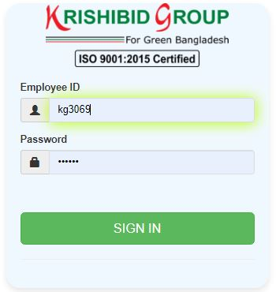

**Figure: 01 KTTL CRM Login Page**

**Logging on ERP System:**

* **Step-1:** Provide Valid **Username and Password. For Username Always Provide your Member ID. (Example: PIAB MemberID: KGXXXX, Password: XXXXXX).**
* **Step-2:** Click on **‘Sign In’** button for go to Home page of PIAB.

# 2. Dashboard

## **2.1 CRM Home Page**

On successful login, a user is directed to the Home Page which consists of the main menu on the left side named dashboard. At the top most part of the system you will have on your left a home icon to denote the home page, a help button- which contains this help manual and the Member Id of the user currently accessing the system.

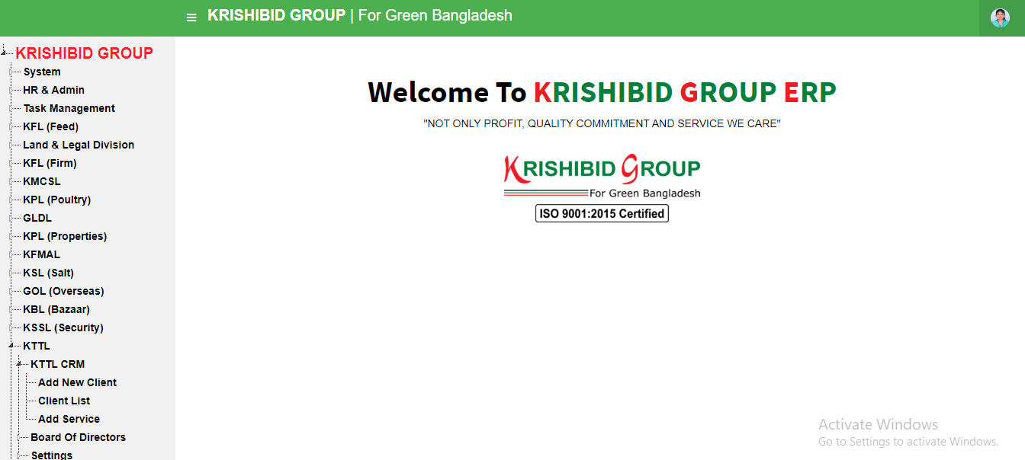The following figure (Fig-02) shows menu bar and home page.

**Figure: 02 CRM Home Page**

* **Step-01:** Click on the Dashboard section under main navigation panel of KG ERP Home Page.

### 2.1.1 Change Password

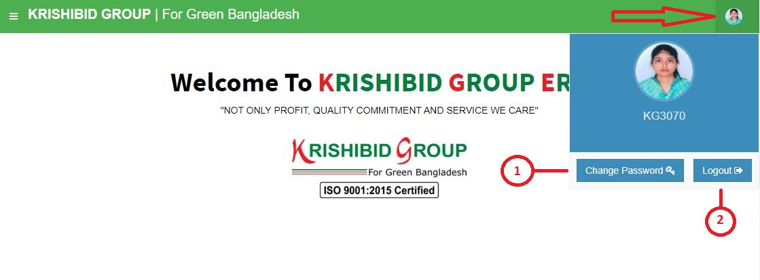In the instance where a user can change his password.

**Figure: 03 Employees Password Change Page (1)**

* **Step-01:** Click on the **PIAB Member ID (KGxxxx)** section under main navigation panel of KGERP software.
* **Step-02:** Click on “**Change Password**” button for changed employees’ password.

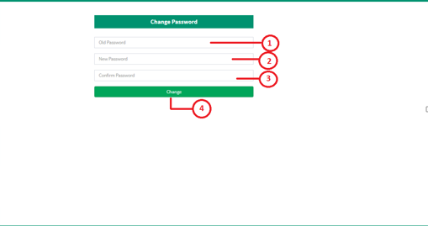

**Figure: 04 CRM Employees Password Change Page (2)**

* **Step-02:** Enter “**Old Password**”, “**New Password**” and “**Confirm Password**” and click on “**Change**” button for changed employee’s current password and new password will be automatically generated. After logout from the PIAB member must enter updated password for entry on ERP.

# KTTL

## **KTTL CRM:**

### 3.1.1 ADD NEW CLIENT

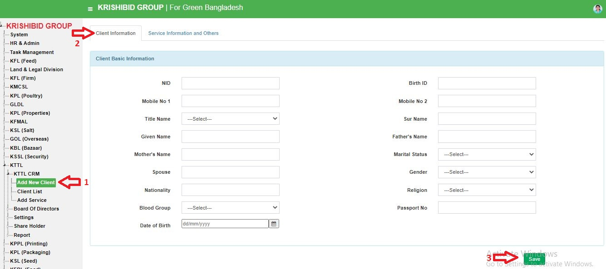The following figure (Fig-05) shows options for CRM.

**Figure: 05 KTTL CRM Add new Client (Client Information)**

* **Step-01:** Click on the **Self Company Information** section under **Member Information** option. The following figure (Fig-05) shows the **Self Company Information Detail of CRM**.

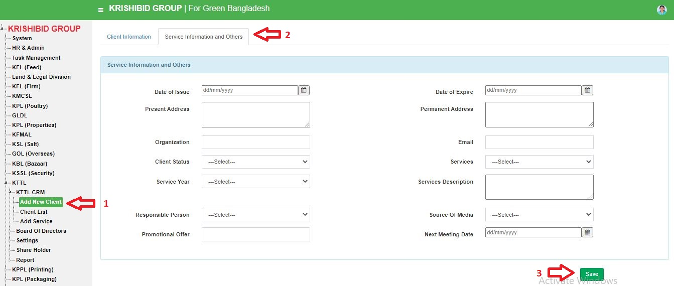The following figure (Fig-06) shows options for CRM new member form.

**Figure: 06 KTTL CRM Add new Client (Service Information and others)**

* **Step-01:** Click on the **Add New Client** section under **Client Information** option. The following figure (Fig-06) shows the new clients information form including Company Basic Information, Concern Person Information, Company Contact Information and Company Logo Details and Save new client on KGERP.

### 3.1.1 Client List

## 

**Fig: 09 Client List**

* **Step-01:** Click on the **Client List** section under **Client Information** option. The following figure (Fig-09) shows the **Client** information.
* **Step-02:** Enter any **“Client Type” or “Name” or “Contact Person” or “Mobile No”, “Email”** in the search section and click on button to search any **Client** info.
* **Step-03:** Click on the **Add New Client** section under **Client** **Information** option. The following figure (Fig-08) shows the client information form including Company Information, Concern Person and Information and Payment Information details. User can add new **Client** by click on save Button.
* **Step-04:** The following figure (Fig-09) shows the clients information form including Company Basic Information, Concern Person Information, Concern Person and Information and Payment Information details. User can modify previous **Client** information on PIAB.
* **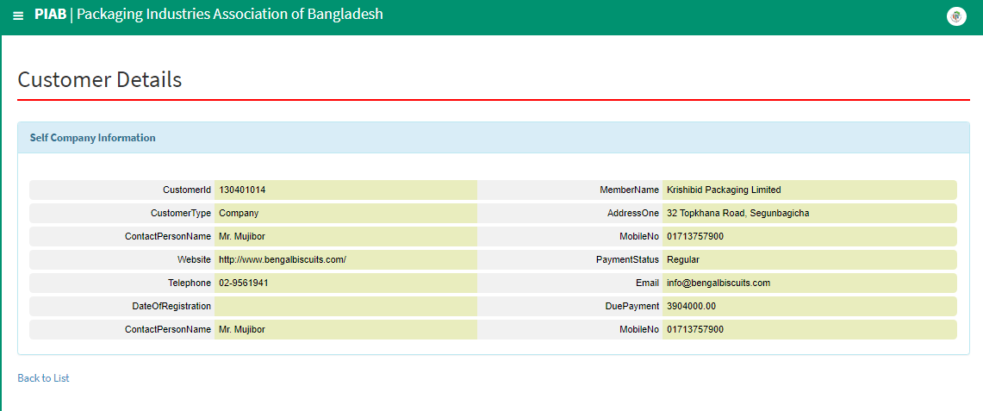****Step-05:** Click on the detail button. The following figure (Fig-10) shows the **Detail of** **Client Information on KTTL**.

**Fig: 10 Client Details**

## **3.3 All Client List**

**Fig: 11 All Client List**

* **Step-01:** Click on the **All Client** section under **Client Information** option. The following figure (Fig-11) shows the **Client** information based on in details.
* **Step-02:** Enter any **“Client Name” or “Type” or “Member Name” or “Mobile No”, or “Payment Status”** in the search section and click on button to search any **Client** info.
* **Step-03:** Click on icon to download individual **Client** Clearance Certificate Report. (Fig: 12).



**Fig: 12 All Client List**